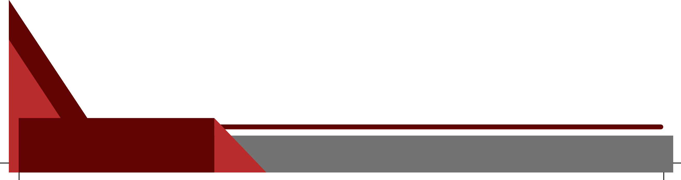

Regards,

Abram Molakeng Managing Director (Property Specialist)

433 Hofmeyer Street, Kaydale, Heidelberg Gauteng

CELL: +27 76 805 5815

[Molakengabram@gmail.com](mailto:Molakengabram@gmail.com)